**CHAPTER 1**

**INTRODUCTION**

A social network is a social structure that maps out the relationships between individuals. It is the relationships that tie us together. social networks facilitate connections between people based on shared interests, values, membership in particular groups. They make it easier for people to find and communicate with individuals who are in their networks using the Web as the interface. Social Networking sites offer people new and varied ways to communicate via the internet. It allows people to create their own online page and to construct and display an online network of contacts, often called friends. Users are able to build a network of connections that they can display as a list of friends. It allows users to share ideas, activities, events, and interests within their individual networks. Social networking is the practice of expanding the number of one's business and/or social contacts by making connections through individuals.  Social Networking establishes connections that help people make contacts that would be good for them to know, but that they would be unlikely to have met otherwise.  It focuses on the building and verifying of online social networks for communities of people who share interests and activities, or who are interested in exploring the interests and activities of others. Most services are primarily web based and provide a collection of various ways for users to interact, such as messaging, queries, Advices and file uploading.

 A social network service consists of a representation of each user (often a profile), his/her social links, and a variety of additional services. Most social network services are [web-based](http://en.wikipedia.org/wiki/Web-based) and provide means for users to interact over the [Internet](http://en.wikipedia.org/wiki/Internet), such as [e-mail](http://en.wikipedia.org/wiki/E-mail) and [instant messaging](http://en.wikipedia.org/wiki/Instant_messaging).

**CHAPTER 2**

**LITERATURE REVIEW**

**2.1 REQUIREMENT ANALYSIS**

The purpose of social network is to provide environment for the users to share their views and ideas with other users. The purpose of social networking is to provide a platform for mutual cooperation between different kind of users, learning by mining. They make it easier for people to find and communicate with individuals who are in their networks using the Web as the interface. Social Networking sites offer people new and varied ways to communicate via the internet. It allows people to create their own online page and to construct and display an online network of contacts, often called friends. Users are able to build a network of connections that they can display as a list of friends. It allows users to share ideas, activities, events, and interests within their individual networks. Social networking is the practice of expanding the number of one's business and/or social contacts by making connections through individuals. Online Social Networking Sites are virtual places that cater to a specific population in which people of similar interest gather to communicate, share and discuss ideas. Many researchers have studied the effects of these networks and most have inferred that they foster relationship building and communications among those involved.

**PROJECT FEATURES:**

* **Messages:**

This application provides the message passing between friends. So communication facility is easy through this application.

* **Edit Profile :**

End users will modify and upload the photos

* **Invite the friends:**

End users send the invitation request to his/her friends. After login the corresponding user he will see the invitation request and two text boxes (Yes, No).If user clicks on the “Yes” then that user is added into community else otherwise that user is just ignored.

* **Groups:**

This application provides users to create a group and invite friends to the created group. This application also allows users to leave a group.

* **Multiple Group posting:**

In this feature you can post a status to multiple groups simultaneously at the same time. This feature use checkboxes to post in multiple groups.

* **Search people:**

This feature enables users to search people by name, email id, male/female.

* **Upload pictures:** In this feature, the user can upload pictures in his/her profile.

.

2.2 **REQUIRMENT SPECIFICATION**

**Existing System:**

Existing System is having Message Sending, Invite the friends, groups and Photo Albums. The existing system is having latency problems which make the web site slow. Existing system does not support multi group posting and they do not have a good instant search engine. In existing system there is no control over spamming and security issues which might cause the web site to get easily hacked by reverse engineering techniques that most hackers around the world to exploit bugs in the system.

Draw Backs:

* Updating is very difficult
* Large volume of data
* Security issues
* Retrieval of Information
* Preparation of information between any two dates at any time
* Multi group posting is not available

Proposed System:

The proposed system rectifies most of the problem in the present system. In the proposed system Message sending, invite the friends, groups, PhotoAlbums and also the multi group posting is available as its main feature. Instant search engine to search the users by name, email id, sex. It is faster than the existing system and it’s most secure. Most of the client request are handled asynchronously by the apache server and therefore its make the website really fast and fun to use.

The main features are:

* Multi group posting.
* Instant search engine.
* Single level comment system.
* Http request are handled using asynchronous cause to the server.
* Web site is fast and highly secure.
* Attractive interface.

**2.3 System Requirement Specification**

**Hardware Requirements:**

* Processor🡪 pentium4 and above
* Memory 🡪 512MB and above
* Storage 🡪2GB free Hard Drive space installed
* Color monitor.
* Keyboard and mouse.
* Internet connection.

**Software Requirements:**

* Operating system 🡪 Any platform with internet enabled web browser
* Database 🡪MySQL
* Graphic card 🡪Direct 9x compatible graphics and flash player plugins
* Browser 🡪 Google Chrome, Mozilla Firefox, Safari, IE9+
* Server 🡪Apache server

**Programming/scripting languages used:**

* HTML5
* CSS3
* JavaScript
* PHP
* MySQL

HTML:

Hyper Text Markup Language (HTML) is the main markup language for web pages. HTML and XHTML are needed to explain the *structure* of any web pages. If you look at this page it is made up of a lot of words. On web pages it is the job of HTML and XHTML to explain the structure of the words — which words form a heading, where paragraphs start and end, and which text should have bullet points. These languages also specify links between different web pages and where images should appear.

HTML elements are the basic building-blocks of webpages.HTML is written in the form of HTML elements consisting of tags enclosed in angle brackets (like <html>), within the web page content. HTML tags most commonly come in pairs like <h1> and </h1>, although some tags, known as empty elements, are unpaired, for example <img>. The first tag in a pair is the start tag, the second tag is the end tag (they are also called opening tags and closing tags). In between these tags web designers can add text, tags, comments and other types of text-based content.

**CSS:**

Cascading Style Sheets (CSS) is a style sheet language used for describing the presentation semantics (the look and formatting) of a document written in a markup language. It’s most common application is to style web pages written in HTML and XHTML, but the language can also be applied to any kind of XML document, including plain XML, SVG and XUL.

CSS is designed primarily to enable the separation of document content (written in HTML or a similar markup language) from document presentation, including elements such as the layout, colors, and fonts. This separation can improve content accessibility, provide more flexibility and control in the specification of presentation characteristics, enable multiple pages to share formatting, and reduce complexity and repetition in the structural content (such as by allowing for table less web design). CSS can also allow the same markup page to be presented in different styles for different rendering methods, such as on-screen, in print, by voice (when read out by a speech-based browser or screen reader) and on Braille-based, tactile devices. It can also be used to allow the web page to display differently depending on the screen size or device on which it is being viewed. While the author of a document typically links that document to a CSS style sheet, readers can use a different style sheet, perhaps one on their own computer, to override the one the author has specified.CSS works by allowing you to associate *rules* with the elements that appear in a web page. These rules govern how the content of those elements should be rendered. CSS rule, which is made up of two parts:

The *selector* , which indicates which element or elements the declaration applies to (if it applies to more than one element, you can have a comma - separated list of several elements)

The *declaration* , which sets out how the elements referred to in the selector should be styled.

**PHP:**

PHP is a general-purpose server-side scripting language originally designed for Web development to produce dynamic Web pages. It is one of the first developed server-side scripting languages to be embedded into an HTML source document, rather than calling an external file to process data. Ultimately, the code is interpreted by a Web server with a PHP processor module which generates the resulting Web page. It also has evolved to include a command-line interface capability and can be used in standalone graphical applications. PHP can be deployed on most Web servers and also as a standalone shell on almost every operating system and platform free of charge. A competitor to Microsoft's Active Server Pages (ASP) server-side script engine and similar languages, PHP is installed on more than 20 million Web sites and 1 million Web servers.

PHP is a server-side scripting language that allows your Web site to be truly dynamic. PHP stands for *Hypertext Preprocessor*. Its flexibility and relatively small learning curve (especially for programmers who have a background in C, Java, or Perl) make it one of the most popular scripting languages around. PHP’s

popularity continues to increase as businesses, and individuals everywhere embrace it as an alternative to Microsoft’s ASP language and realize that PHP’s benefits most certainly outweigh the costs (three cheers for open source!). According to Netcraft, PHP code can now be found in approximately 16 million

Web sites. The version of PHP referenced in this book is the most recent stable release at the time of publication: version 5.0.0. Although we discuss several of the most common uses and functions of PHP, you can find a complete list of PHP functions in Appendix B of this book. As you continue to program in PHP and

your comfort level increases (or the demands of your boss grow), we encourage you to expand your use of built-in PHP functions to take advantage of its tremendous power. You can download the PHP software from PHP’s Web site at www.php.net.

**JAVA SCRIPT:**

JavaScript is a prototype-based scripting language that is dynamic, weakly typed and has first-class functions. It is a multi-paradigm language, supporting object-oriented, imperative, and functional programming styles.

JavaScript was formalized in the ECMA Script language standard and is primarily used in the form of client-side JavaScript, implemented as part of a Web browser in order to provide enhanced user interfaces and dynamic websites. This enables programmatic access to computational objects within a host environment.

* JavaScript's use in applications outside Web pages — for example in PDF documents, site-specific browsers, and desktop widgets — is also significant. Newer and faster JavaScript VMs and frameworks built upon them (notably Node.js) have also increased the popularity of JavaScript for server-side web applications.
* **JavaScript gives HTML designers a programming tool -**HTML authors are normally not programmers, but JavaScript is a scripting language with a very simple syntax! Almost anyone can put small "snippets" of code into their HTML pages
* **JavaScript can react to events -**A JavaScript can be set to execute when something happens, like when a page has finished loading or when a user clicks on an HTML element
* **JavaScript can read and write HTML elements -**A JavaScript can read and change the content of an HTML element
* **JavaScript can be used to validate data -**A JavaScript can be used to validate form data before it is submitted to a server. This saves the server from extra processing

**MySQL:**

MySQL is the world's most used relational database management system (RDBMS) that runs as a server providing multi-user access to a number of databases. It is named after developer Michael Widenius' daughter, My SQL phrase stands for Structured Query Language. The MySQL development project has made its source code available under the terms of the GNU General Public License, as well as under a variety of proprietary agreements. MySQL was owned and sponsored by a single for-profit firm, the Swedish company MySQL AB, now owned by Oracle Corporation. Another open source favorite, MySQL is the database construct that enables PHP and Apache to work together to access and display data in a readable format to a browser. It is a Structured Query Language

server designed for heavy loads and processing of complex queries. As a relational database system, MySQL allows many different tables to be joined together for maximum efficiency and speed.

**BROWSER:**

A web browser is a software application for retrieving, presenting, and traversing information resources on the World Wide Web. An information resource is identified by a Uniform Resource Identifier (URI) and may be a web page, image, video, or other piece of content. Hyperlinks present in resources enable users easily to navigate their browsers to related resources. A web browser can also be defined as an application software or program designed to enable users to access, retrieve and view documents and other resources on the Internet.

Although browsers are primarily intended to access the World Wide Web, they can also be used to access information provided by web servers in private networks or files in file systems. The major web browsers are Firefox, Google Chrome, Internet Explorer, Opera, and Safari.

UML:

Unified Modeling Language (UML) is a standardized general-purpose modeling language in the field of object-oriented software engineering. The standard is managed, and was created, by the Object Management Group. It was first added to the list of OMG adopted technologies in 1997, and has since become the industry standard for modeling software-intensive systems.

**2.4 DESIGN**

**2.4.1UML DIAGRAMS:**

a) Use case

A use case diagram in the Unified Modeling Language (UML) is a type of behavioral diagram defined by and created from a Use-case analysis. Its purpose is to present a graphical overview of the functionality provided by a system in terms of actors, their goals (represented as use cases), and any dependencies between those use cases. ( Ref fig:- 2.4.1 a ).

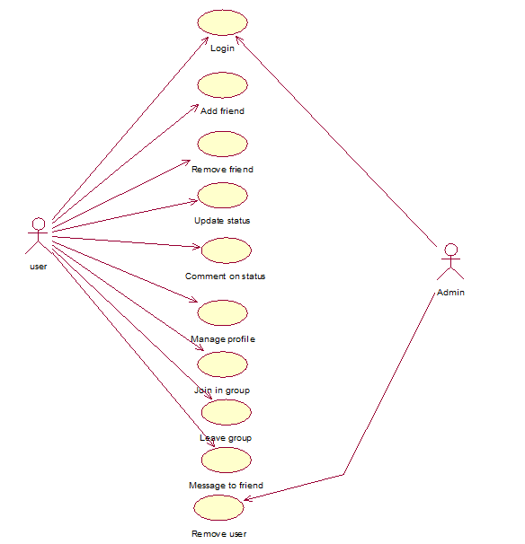

Fig 2.4.1 a): Use-case diagram

The main purpose of a use case diagram in this application is to show what system functions are performed for which actor. Roles of the actors in the system can be depicted.

b) Sequence diagram

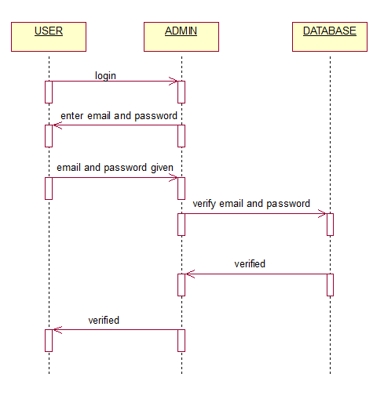

Fig 2.4.1 b): Sequence diagram

A sequence diagram in a Unified Modeling Language (UML) is a kind of interaction diagram that shows how processes operate with one another and in what order. It is a construct of a Message Sequence Chart. A sequence diagram shows object interactions arranged in time sequence. It depicts the objects and classes involved in the scenario and the sequence of messages exchanged between the objects needed to carry out the functionality of the scenario. Sequence diagrams typically are associated with use case realizations in the Logical View of the system under development.

Sequence diagrams are sometimes called event diagrams, event scenarios, and timing diagrams. ( Ref fig:- 2.4.1 b ).

c) Activity diagram

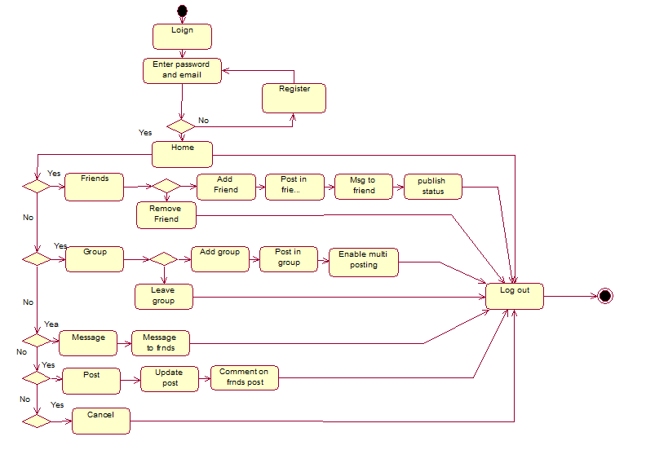

Fig 2.4.1 c): Activity diagram

Activity diagrams are graphical representations of workflows of stepwise activities and actions with support for choice, iteration and concurrency. In the Unified Modeling Language, activity diagrams can be used to describe the business and operational step-by-step work flows of components in a system. An activity diagram shows the overall flow of control. ( Ref fig:- 2.4.1 c ).

**2.4.2 Data Flow diagram:**

Client provides the data to the server administration through the Social Networking System. Here the server administration checks the data that is provided by the client with the client original data i.e the data provided by the client at registration. If the data matches the server administration provides authentication to the client.

(Ref fig:- 2.4.2).

.

SERVER ADMINISTRATION

.

.

PROVIDES AUTHENTICATION

CLIENT

REGISTER AN ACCOUNT

DEVELOPED PROFILE

Fig 2.4.2: Data flow diagram

**2.4.3 Architectural diagram:**

The main components of the system architecture contains the browsers, HTTP (request and response), html & php pages and the MySQL server. The sending data is append with the HTTP request and sent to the server. The server then processes the HTTP request and retrieve data from the MySQL database and send the response back to the browser. The browser send HTTP request to the server and the server checks HTTP request and sends the data in the xml format to the database.

The information flow starts in the system with user login or register to the application. After registration the user’s information is stored into the database. At

Login the user is asked for correct user id and password. (Ref Fig 2.4.3)

Html and php pages

MySQL Server

HTTP

Request🡪

🡨Response

Internet

Explorer

Mozilla

Firefox

Google

chrome

Netscape Navigator

Html and php

Html and php

Html and php

Html and php

MySQL database

Html and php

Html and php

Html and php

Browsers

.

Apache Server

.

Fig 2.4.3: Architecture diagram

**2.4.4 MODULE DESIGN**

Knowledge Based community Sharing System has different types of modules; here we are discussing a few of them:

* Registration
* Messaging
* Edit profile
* Uploading picture
* Create groups
* Group posting
* Multi group posting
* Instant search engine

**Registration:**

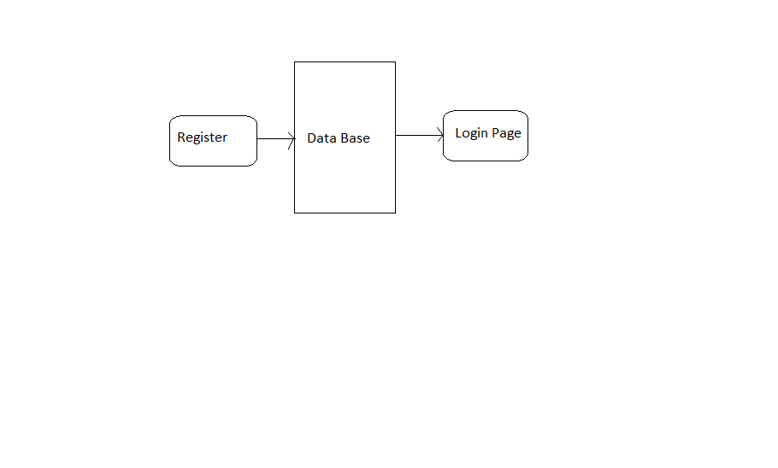Fig 2.4.4 a): Registration module

The new users, first have to register with correct information if not they will not be able to register, after registration, the details are stored in the database and now they can go to home page. Here the registered information is sent into the database. During registration the data are checked by the database, if it exists or not. In case the user information is already present in the database, it will not accept and asked for new information. (Ref fig:-2.4.4 a)

**Messaging:**

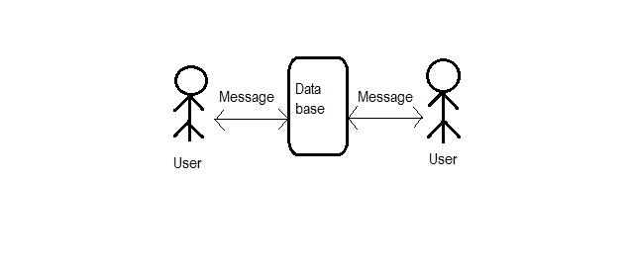

Fig 2.4.4 b) Messaging module

Messaging is two way communications between two users. The community members who all are in the chat in the community are visible and they can do conversation to each other. This helps the user to discuss everything.

Here the user sends the message to the database where the message is stored and then delivered it to the other user. The other user’s message was also stored in the data base and delivered it the first user. (Ref fig:-2.4.4 b)

**Uploading picture:**

Form

Server

Form Submit

Picture

Fig 2.4.4 c) Uploading picture module

The picture to be uploaded is submitted in a form and stored in the server.

For uploading a picture, the user have to choose pictures from his/her hard disks. Then from the hard disks the picture will be submitted to the server where it is stored. (Ref fig:-2.4.4 c)

**Groups:**

Server

Create group

Fig 2.4.4 d) Groups module

Groups are created by the users and saved into the database. In creating a group the user have to provide group name and the name is stored into the server. The user can add as many friends he/she wants. It also has the functionality that the invited friends can leave the group too. (Ref fig:-2.4.4 d)

**2.5 IMPLEMENTATION**

The implementation phase of software development is concerned with translating design specifications into source code. The primary goal of implementation is to write source code and internal documentation so that conformance of the code to its specifications can be easily verified, and so that debugging, testing and modification are eased. This goal can be achieved by making the source code as clear and straightforward as possible.

**Registration:** The registration enables the user for take the full ad.vantage of web application, the user has to register with this site through the registration page. The user will need to provide information such as email, user id, password, etc.

**Login:** This module deals with the login process. Entered data will be matched with the database (Mysql).a valid set of user name and a person can log in the page. After gaining access to the system, they can utilize the available facilities.

**Create group:** The user can create groups and invite friends to join his/her group.It also allows them leave or join the group.

**Messaging:** This messaging is done with the friends that he has added in his/her friend list. This process is kept to discuss the information immediately with anyone.

**Multi group posting:** This module allows the user to post in multiple groups simultaneously. The user write the post and post it in multiple groups by checkboxes.

**2.6 TESTING**

Software testing is an important element of the software quality assurance and represents the ultimate review of specification, design and coding. The increasing feasibility of software as a system and the cost associated with the software failures are motivated forces for well planned through testing.

**Testing Objectives**

These are several rules that can save as testing objectives they are:

* Testing is a process of executing program with the intent of finding an error.
* A good test case is one that has a high probability of finding an undiscovered error.

**Testing procedures for the project is done in the following sequence**

* System testing is done for checking the server name of the being connected between the admin and user..
* The information provided by the User to the admin is tested against the validation with the centralized data store.

System testing is also done for checking the admin availability to connect to the server.

* The server name authentication is checked and availability to the User.
* Proper communication chat line availability is tested and made the chat system function properly.

**Unit Testing**

Unit testing focuses verification effort on the smallest unit of software design module. Important of tests and uncovered errors is limited by the constrained scope established for unit testing. In unit testing, each module is tested separately. In this project web page are evaluated by unit testing.

**Integration Testing**

Integration testing is a systematic technique for constructing the program structure while conducting tests to uncover errors associated with interfacing. The objective is to take unit tested modules and build a program structure that has been dictated by design.

There are two strategies in integration testing.

* Top-down Integration
* Bottom-up Integration.

In **Top-down integration** modules are integrated by moving downward through the control hierarchy, beginning with the main control module. **Bottom-up integration** testing begins construction and testing with atomic modules. That is, modules at the lowest levels in the program structure.

This project follows bottom-up integration.

**Validation Testing**

Validation is the process of evaluating software at the end of the software development process to determine compliance with the requirements, various validations. In this project, Textbox is the input box for getting the user's inputs. If the user does not enter the correct data type mismatch data type error will be occurred.

**TEST CASES FOR TWO SAMPLE MODULES:**

**Registration:**

|  |  |  |  |  |  |  |
| --- | --- | --- | --- | --- | --- | --- |
| Sl.No | Test Case ID | Step | Data | Expected Result | Actual Result | Remarks |
| 1. | T001 | Enter first name  “Add Entry” | First Name:  Ranix | Error:One or more field is left blank | Error:One or more field is left blank | pass |
| 2. | T002 | Enter first name,last name  “Add Entry” | First Name:  Ranix  Last Name:  Das | Error:One or more field is left blank | Error:One or more field is left blank | pass |
| 3. | T003 | Enter first name,last name,password  “Add Entry” | First Name:  Ranix  Last Name:  das  Password:123456 | Error:One or more field is left blank | Error:One or more field is left blank | pass |
| 4. | T004 | Enter first name,last name,password,re enterpassword  “Add Entry” | First Name:  Ranix  Last Name:  das  Password:123456  Re enterpassword:123456 | Error:One or more field is left blank | Error:One or more field is left blank | pass |
| 5. | T005 | Enter first name,last name,password,re enterpassword,email  “Add Entry” | First Name:  Ranix  Last Name:  das  Password:123456  Re enterpassword:123456  Email:drramesh0108@gmail.com | Succesful entry addition message | Registered | pass |

Table No. :- 1

**Login:**

|  |  |  |  |  |  |  |
| --- | --- | --- | --- | --- | --- | --- |
| Sl.No | Test Case ID | Step | Data | Expected Result | Actual Result | Remarks |
| 1. | T001 | Enter first name  “Add Entry” | First Name:Ranix | Error: One or more field is left blank | Error: One or more field is left blank | pass |
| 2. | T002 | Enter first name, last name  “Add Entry” | First Name:Ranix  Last Name:das | Error: One or more field is left blank | Error: One or more field is left blank | pass |
| 3. | T003 | Enter first name, last name,password  “Add Entry” | First Name:  Ranix  Last Name:  das  Password:123456 | Error: One or more field is left blank | Error: One or more field is left blank | pass |
| 4. | T004 | Enter first name, last name,password,re enterpassword  “Add Entry” | First Name:  Ranix  Last Name:  das  Password:123456  Re enterpassword:123456 | Error: One or more field is left blank | Error: One or more field is left blank | pass |
| 5. | T005 | Enter first name,last name,password,re enterpassword,email  “Add Entry” | First Name:Ranix  Last Name:das  Password:123456  Re enterpassword:123456  Email:drramesh0108@gmail.com | Successful entry addition message | Registered | pass |

Table No. :- 2

**Database:**

LIST OF TABLES IN DATABASE

* Friends
* Groups
* Grpmem
* Grpposts
* Messages
* Posts
* Profile
* users

Users:

|  |  |
| --- | --- |
| **Attribute** | **Data Type** |
| userid | Int |
| email | Varchar(50) |
| password | Varchar(50) |
| firstname | Varchar(50) |
| lastname | Varchar(50) |
| sex | Varchar(13) |
| dob | Varchar(30) |
| pic | Varchar(50) |

Table No. :- 1

Message:

|  |  |
| --- | --- |
| **Attribute** | **Data Type** |
| mid | Int |
| userid | Varchar(50) |
| touserid | Varchar(50) |
| mtext | text |
| time | int(50) |

Table No. :- 2

Post:

|  |  |
| --- | --- |
| **Attribute** | **Data Type** |
| p_id | Int |
| userid | Varchar(50) |
| ref | Varchar(50) |
| postfor | Varchar(50) |
| posttext | Varchar(50) |
| time | Varchar(13) |

Table No. :- 3

Friends:

|  |  |
| --- | --- |
| **Attribute** | **Data Type** |
| friend1 | Int |
| friend2 | Varchar(50) |
| status | Varchar(50) |

Table No. :- 4

Groups:

|  |  |
| --- | --- |
| **Attribute** | **Data Type** |
| grpid | Int |
| time | Varchar(50) |
| admin | Varchar(50) |
| name | Varchar(50) |

Table No. :- 5

Groupmem:

|  |  |
| --- | --- |
| **Attribute** | **Data Type** |
| grpid | Int |
| memid | Varchar(50) |
| status | Varchar(50) |

Table No. :- 6

Grouppost:

|  |  |
| --- | --- |
| **Attribute** | **Data Type** |
| p_id | Int |
| grpid | Varchar(50) |
| userid | Varchar(50) |
| ref | Varchar(50) |
| posttext | Varchar(50) |
| time | Varchar(13) |

Table No. :- 7

Profile:

|  |  |
| --- | --- |
| **Attribute** | **Data Type** |
| userid | Int |
| currentcity | Varchar(50) |
| hometown | Varchar(50) |
| interest | Varchar(50) |
| about | Varchar(50) |

Table No. :- 8

**index.php :**

<?php

session_start();

if(!isset($_SESSION['token'])&&!isset($_SESSION['name'])){

if(empty($_SESSION['token'])&&empty($_SESSION['name'])){

header('Location:login.php');

}

}

?>

<!DOCTYPE html>

<html lang="en">

<head>

<meta charset="utf-8">

<title>Mitragan</title>

<meta name="viewport" content="width=device-width, initial-scale=1.0">

<meta name="description" content="This i my site description">

<meta name="author" content="Ranix Das, Ravi Arya, Saurabh Anand">

<!-- Le styles -->

<link href="bootstrap/css/bootstrap.css" rel="stylesheet">

<link rel="shortcut icon" href="bootstrap/img/img-edit.jpg">

<link href="bootstrap/css/bootstrap-responsive.css" rel="stylesheet">

<style type="text/css">

body {

background:url("bootstrap/img/social-network.jpeg");

background-attachment:fixed;

padding-top: 40px;

padding-bottom: 40px;

opacity:0.9;

}

.login-top{

margin-top:6px;

margin-bottom:0px;

}

.sidebar-nav {

padding: 9px 0;

}

.sideitem{

cursor:pointer;

}

</style>

<!-- Le HTML5 shim, for IE6-8 support of HTML5 elements -->

<!--[if lt IE 9]>

<script src="//html5shim.googlecode.com/svn/trunk/html5.js"></script>

<![endif]-->

<!-- Le fav and touch icons -->

<!--<link rel="shortcut icon" href="images/favicon.ico">

<link rel="apple-touch-icon" href="images/apple-touch-icon.png">

<link rel="apple-touch-icon" sizes="72x72" href="images/apple-touch-icon-72x72.png">

<link rel="apple-touch-icon" sizes="114x114" href="images/apple-touch-icon-114x114.png">-->

</head>

<body onload="init();">

<div class="navbar navbar-fixed-top">

<div class="navbar-inner">

<div class="container-fluid">

<div class="nav-collapse pull-right">

<ul class="nav">

<li class="dropdown">

<a href="#" class="dropdown-toggle" data-toggle="dropdown">Options <b class="caret"></b></a>

<ul class="dropdown-menu">

<li><a>Profile</a></li>

<li><a href="#two">Settings</a></li>

<li class="divider"></li>

<li><a href="logout.php">Log out</a></li>

</ul>

</li>

</ul>

</div>

<a class="brand" href="index.php">Social Network</a>

</div>

</div>

</div>

<div id="page" style="background:white;">

<div class="container-fluid">

<div class="row-fluid">

<div class="span2">

<div class="well sidebar-nav">

<?php

require'connect.inc.php';

$id=$_SESSION['token'];

$sql="select * from users where userid='$id'";

if($query_row=mysql_query($sql)){

$result=mysql_fetch_assoc($query_row);

$sex=$result['sex'];

$pic=$result['pic'];

if($pic==''&&$sex=='male'){

$a="male-user.jpg";

}else if($pic==''&&$sex=='female'){

$a="female-user.jpg";

}else{

$a=$pic;

}

}

?>

<h3 style="margin-left:10px"><?php echo $result['firstname'].' '.$result['lastname'];?></h3>

<img src="<?php echo 'uploads/'.$a ?>" width="150" style="border-radius:4px 4px 4px 4px;margin-left:10px;"/>

<ul class="nav nav-list">

<li><a class="sideitem" onclick="cropnsave(this);"> <i class="icon-picture"></i>Edit Picture</a></li>

<li id="editprofile"><a class="sideitem" onclick="editp();"> <i class="icon-pencil"></i>Edit Profile</a></li>

<li><a class="sideitem" href="gallery.php"> <i class="icon-camera"></i>Gallery</a></li>

<li class="nav-header">Favourites</li>

<li class="active" id="newsitem"><a class="sideitem" onclick="getnews();"> <i class="icon-list-alt"></i>News</a></li>

<li><a class="sideitem"> <i class="icon-envelope"></i>Messages</a></li>

<li><a class="sideitem" onclick="showrequests();"> <i class="icon-envelope"></i>Friend Requests</a></li>

<li id="searchitem"class=""><a onclick="searchppl();"> <i class="icon-user"></i>Find People</a></li>

<li><a class="sideitem"> <i class="icon-cog"></i>Settings</a></li>

<li class="nav-header">Groups</li>

<?php

require 'connect.inc.php';

$userid=$_SESSION['token'];

$sql="SELECT * FROM grpmem where memid='$userid';";

$query_row=mysql_query($sql);

while($result=mysql_fetch_assoc($query_row)){

$grpid=$result['grpid'];

$sql1="SELECT * FROM groups where grpid='$grpid';";

$query_row1=mysql_query($sql1);

$result1=mysql_fetch_assoc($query_row1);

$name=$result1['name'];

echo "<li><a class='sideitem' id='grp$grpid' name='$name' onclick='getgrp(this);'> <i class='icon-th'></i>$name</a></li>";

}

?>

<li id="creategrp"><a class="sideitem" onclick="creategrp();"><i class='icon-plus'></i>Create Group</a></li>

</ul>

</div><!--/.well -->

</div><!--/span-->

<div class="span8">

<div id="main" style="background:white;">

</div>

</div><!--/span-->

<div class="span2">

<div class="well sidebar-nav">

<ul class="nav nav-list">

<li class="nav-header">Sharing Options</li>

<li><a href="#">Multi Group Post</a></li>

<li class='nav-header'>Friends</li>

<div id="right-sidebar">

</div>

</ul>

</div><!--/.well -->

</div><!--/span-->

</div><!--/row-->

</div>

<div class="container-fluid">

<hr>

<footer>

<p>&copy; Social Network 2012</p>

</footer>

</div><!--/.fluid-container-->

<!-- Placed at the end of the document so the pages load faster -->

<script src="bootstrap/js/jquery-1.7.2.min.js"></script>

<script type="text/javascript">

function createRequest()

{

try{

request=new XMLHttpRequest();

}catch(tryMS){

try{

request=new ActiveXObject("Msxml2.XMLHTTP");

}catch(otherMS){

try{

request=new ActiveXObject("Microsoft.XMLHTTP");

} catch(failed){

request=null;

}

}

}

return request;

}

function showrequests(){

$('#main').html('<h2>Friend Notifications</h2><div id="_req">');

$.get("notifications.php",function(result){

$('#_req').html(result);

$('#_req').addClass('well');

});

}

function replyreq(a,b){

$(b).parent().parent().fadeOut(500);

$.get("acceptreq.php?frdid="+a,function(result){});

populatefriends();

}

function rejectreq(a,b){

$(b).parent().parent().fadeOut(500);

$.get("rejectreq.php?frdid="+a,function(result){});

}

function joingrp(a,b){

$(b).parent().fadeOut(500);

$.get("joingrp.php?grpid="+a,function(result){});

}

function cropnsave(a){

$.get("editpic.php",function(result){

$('#main').html(result);

});

}

function populatefriends(){

$.get("getfriends.php",function(result){

$('#right-sidebar').html(result);

});

}

function init(){

getnews();

populatefriends();

}

**news.php :**

<div>

<form class="well">

<h4>Update status</h4>

<textarea class="span6" id="postbox"></textarea>

<br>

<input class="btn btn-primary" type="button" value="Share" onclick="savepost();" />

</form>

</div>

<div id="_post">

</div>

**users.php :**

<?php

session_start();

if(!isset($_SESSION['token'])&&!isset($_SESSION['name'])){

$userid=$_SESSION['token'];

if(empty($_SESSION['token'])&&empty($_SESSION['name'])){

header('Location:login.php');

}

}

?>

<!DOCTYPE html>

<html lang="en">

<head>

<meta charset="utf-8">

<title>Mitragan</title>

<meta name="viewport" content="width=device-width, initial-scale=1.0">

<meta name="description" content="This i my site description">

<meta name="author" content="Ranix Das, Ravi Arya, Saurabh Anand">

<!--Le styles -->

<link href="bootstrap/css/bootstrap.css" rel="stylesheet">

<link rel="shortcut icon" href="bootstrap/img/img-edit.jpg">

<link href="bootstrap/css/bootstrap-responsive.css" rel="stylesheet">

<style type="text/css">

body {

background:url("bootstrap/img/social-network.jpeg");

background-attachment:fixed;

padding-top: 40px;

padding-bottom: 40px;

opacity:0.9;

}

.login-top{

margin-top:6px;

margin-bottom:0px;

}

.sidebar-nav {

padding: 9px 0;

}

.sideitem{

cursor:pointer;

}

**savepost.php :**

<?php

session_start();

if(isset($_SESSION['token'])){

$userid=$_SESSION['token'];

if(isset($_GET['_p'])){

if(!empty($_GET['_p'])){

$p=$_GET['_p'];

$time=time();

require 'connect.inc.php';

if(isset($_GET['_uid'])){

if(!empty($_GET['_uid'])){

$uid=$_GET['_uid'];

}

}else{

$uid=$userid;

}

$sql="INSERT INTO `posts`(`userid`,`posttext`,`time`,`postfor`) VALUES('$userid','$p','$time','$uid')";

mysql_query($sql);

$sql="SELECT * from posts where `time`='$time';";

$query_row=mysql_query($sql);

$result=mysql_fetch_assoc($query_row);

$id=$result['p_id'];

// Start XML file, create parent node

$dom = new DOMDocument("1.0");

$node = $dom->createElement("posts");

$parnode = $dom->appendChild($node);

if(isset($_GET['_uid'])){

if(!empty($_GET['_uid'])){

$uid=$_GET['_uid'];

}

}else{

$uid=$userid;

}

$sql="SELECT * FROM posts where postfor='$uid' and ref='0' order by time desc";

$result=mysql_query($sql);

header("Content-type: text/xml");

// Iterate through the rows, adding XML nodes for each

while ($row = @mysql_fetch_assoc($result)){

$node = $dom->createElement("post");

$newnode = $parnode->appendChild($node);

$newnode->setAttribute("post_id", $row['p_id']);

$newnode->setAttribute("userid", $row['userid']);

$a=$row['userid'];

$sql1="select * from users where userid='$a';";

$queryrow1=mysql_query($sql1);

$result1=mysql_fetch_assoc($queryrow1);

$firstname=$result1['firstname'];

$lastname=$result1['lastname'];

$newnode->setAttribute("posttext",$row['posttext']);

$newnode->setAttribute("time",$row['time']);

$newnode->setAttribute("firstname",$firstname);

$newnode->setAttribute("lastname",$lastname);

$newnode->setAttribute("ref",$row['ref']);

$time=$row['time'];

$d=date("d",$time);

$m=date("m",$time);

$y=date("Y",$time);

$hr=date("H",$time);

$min=date("i",$time);

$sec=date("s",$time);

$newnode->setAttribute("d",$d);

$newnode->setAttribute("m",$m);

$newnode->setAttribute("y",$y);

$newnode->setAttribute("H",$hr);

$newnode->setAttribute("i",$min);

$newnode->setAttribute("s",$sec);

**getspost.php :**

<?php

$ref=$row['p_id'];

$s="select * from posts where ref='$ref' order by time;";

$r=mysql_query($s);

while ($crow = @mysql_fetch_assoc($r)){

$cnode = $dom->createElement("comment");

$cnewnode = $newnode->appendChild($cnode);

$cnewnode->setAttribute("p_id", $crow['p_id']);

$cnewnode->setAttribute("userid", $crow['userid']);

$cnewnode->setAttribute("posttext",$crow['posttext']);

$cnewnode->setAttribute("time",$crow['time']);

$a=$crow['userid'];

$sql1="select * from users where userid='$a';";

$queryrow1=mysql_query($sql1);

$result1=mysql_fetch_assoc($queryrow1);

$firstname=$result1['firstname'];

$lastname=$result1['lastname'];

$cnewnode->setAttribute("firstname",$firstname);

$cnewnode->setAttribute("lastname",$lastname);

$cnewnode->setAttribute("ref",$crow['ref']);

$time=$crow['time'];

$d=date("d",$time);

$m=date("m",$time);

$y=date("Y",$time);

$hr=date("H",$time);

$min=date("i",$time);

$sec=date("s",$time);

$cnewnode->setAttribute("d",$d);

$cnewnode->setAttribute("m",$m);

$cnewnode->setAttribute("y",$y);

$cnewnode->setAttribute("H",$hr);

$cnewnode->setAttribute("i",$min);

$cnewnode->setAttribute("s",$sec);

$timenow=time();

$timediff=$timenow-$time;

$days = round(($timediff % 604800) / 86400, 2);

$hours = round((($timediff % 604800) % 86400) / 3600, 2);

$minutes = round(((($timediff % 604800) % 86400) % 3600) / 60, 2);

$seconds = round((((($timediff % 604800) % 86400) % 3600) % 60), 2);

$cnewnode->setAttribute("d1",$days);

$cnewnode->setAttribute("h1",$hours);

$cnewnode->setAttribute("i1",$minutes);

$cnewnode->setAttribute("s1",$seconds);

}

}

echo $dom->saveXML();

}

?>

**message.php :**

<h2>Messages</h2>

<?php

session_start();

require 'connect.inc.php';

if(isset($_SESSION['token'])){

$userid=$_SESSION['token'];

if(!empty($userid)){

if(isset($_GET['_uid'])){

if(!empty($_GET['_uid'])){

$uid=$_GET['_uid'];

$sql="select * from messages where (userid='$userid' or userid='$uid') and (touserid='$userid' or touserid='$uid')order by time;";

if($result=mysql_query($sql)){

echo "<div class='well'>";

while($row=mysql_fetch_assoc($result)){

$id=$row['userid'];

$text=$row['mtext'];

$sql1="select * from users where userid='$id';";

$result1=mysql_query($sql1);

$row1=mysql_fetch_assoc($result1);

$name=$row1['firstname']." ".$row1['lastname'];

echo "<b>$name</b> : $text<br>";

}}

echo "</div>";

}

}

}

}

?>

<form class="well" method="POST">

<input type="text" id="_text" name="_text" /><br>

<input type="button" class="btn btn-primary" onclick="savemsg();" value="Send"/>

</form>

**grouplist.php:**

<?php

session_start();

require 'connect.inc.php';

$userid=$_SESSION['token'];

if(isset($_GET['_uid'])){

if(!empty($_GET['_uid'])){

$uid=$_GET['_uid'];

}

}else{

$uid=$userid;

}

$sql="SELECT * FROM grpmem where memid='$uid';";

$query_row=mysql_query($sql);

while($result=mysql_fetch_assoc($query_row)){

$grpid=$result['grpid'];

$sql1="SELECT * FROM groups where grpid='$grpid';";

$query_row1=mysql_query($sql1);

$result1=mysql_fetch_assoc($query_row1);

$name=$result1['name'];

echo "<li><i class='icon-th'></i>$name</li>";

}

?

**2.8 SCREENSHOTS:**

**Login page:**

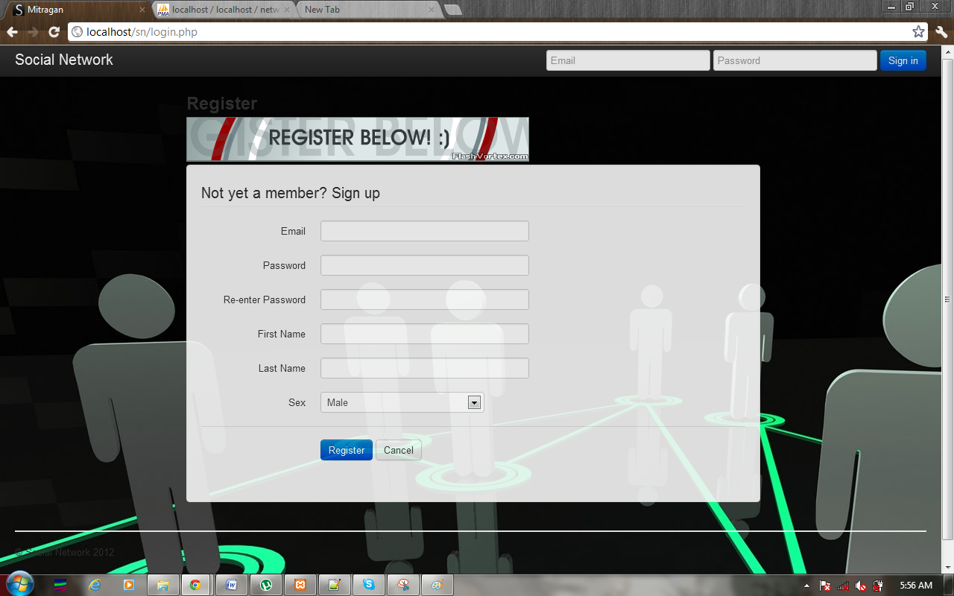

Fig No:- 2.8.1

**Home page:**

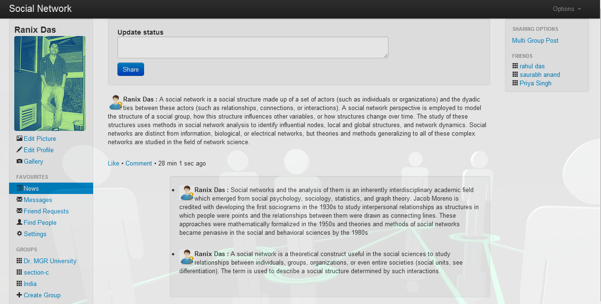

Fig No:- 2.8.2

**Create Group:**

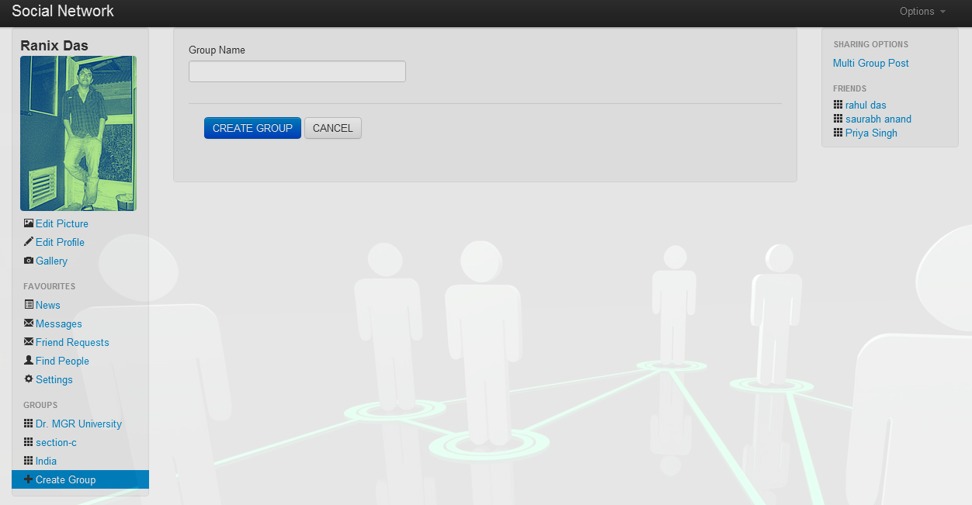

Fig No:- 2.8.3

**Group:**

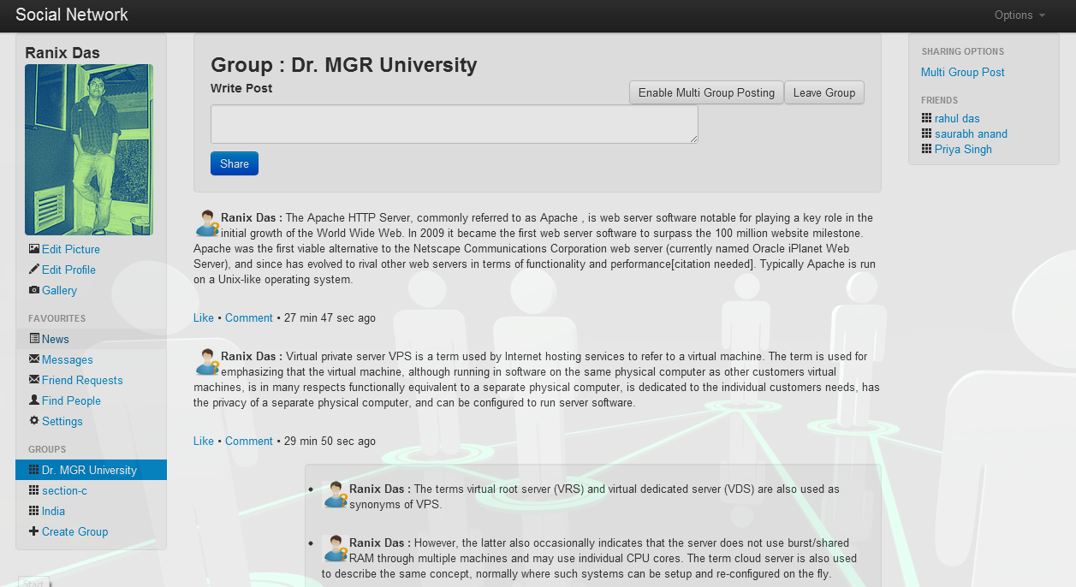

Fig No:- 2.8.4

**Enable Multi - Group Posting:**

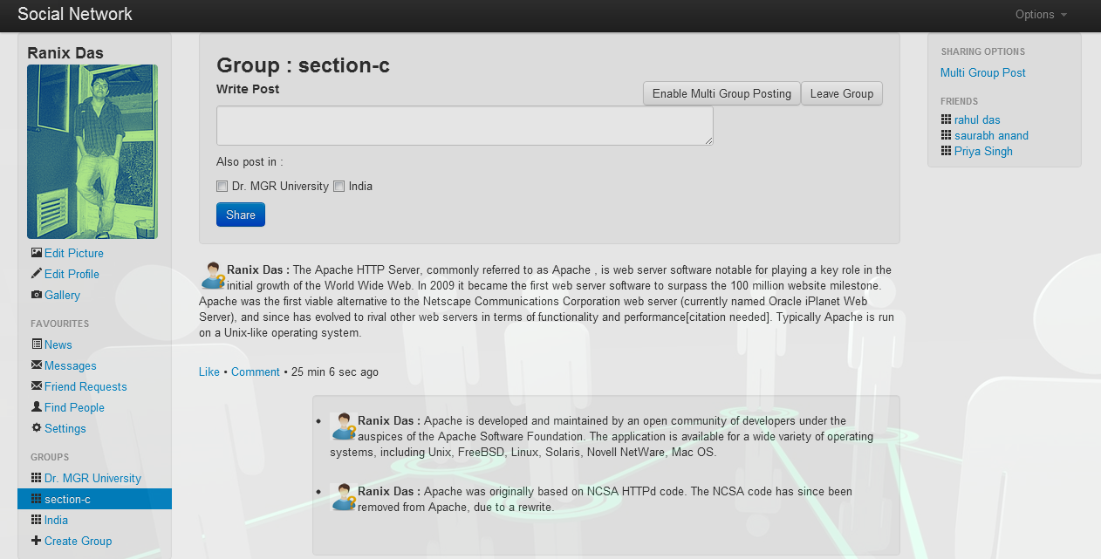

Fig No:- 2.8.5

**Messages:**

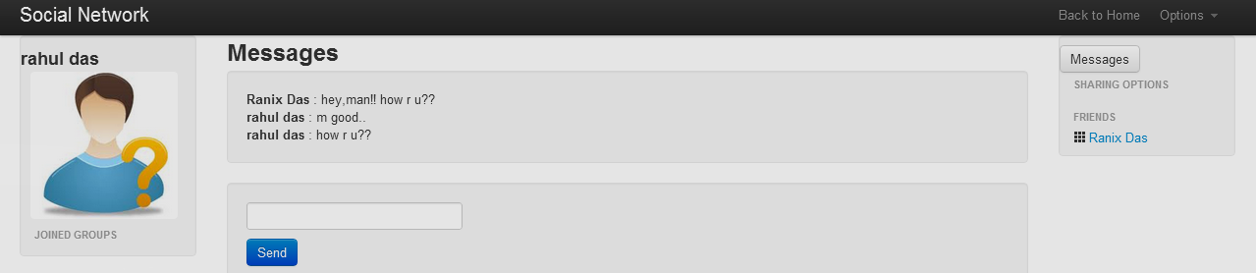

Fig No:- 2.8.6

**Search:**

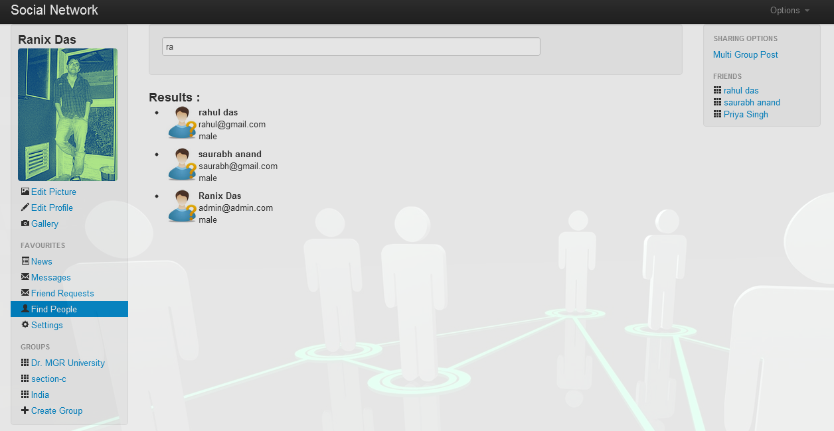

Fig No:- 2.8.7

**CHAPTER 3: CONCLUSION**

Social Networking website is a revolutionary idea with a very bright future with further scope for advancements. The opportunities provided from this medium are immense and many organisations are making use of this medium to better their practices. Organisations are no longer at the mercy of the media to advertise or convey their message. With the help of social networking they can advertise or communicate in a more efficient way .Similarly people don’t have to rely on newspapers or TV to get their daily dose of news it can all be obtained from a social networking site. People can follow or get information from any part of the world. Online communities and Blogs are becoming very popular and moreover since the advancement of embedded systems people can use them “on the go” with the help of handheld devices like cell phones. They can get information which is more interactive in nature with the help of embed photo and video. The kind of interaction a user wants from these social networks depends on the type of information the user is interested in. Wikis can be used for academic purpose, it can greatly enhance the way people learn.

The world is getting closer everyday and everyone wants to be connected. Static blogs and websites are losing popularity. The information comes to users rather than users have to make effort to get the information. In terms of personal relationships too the social networking is connecting people. Dating sites have become very popular to find partners and to be connected with each other

After all the advantages, the problem that arises is of information overload and security. Social networks, unlike the common media, do not have a pattern as to how much information has to be conveyed and where to draw the line. Too much of information may confuse users. Security might be another area of concern where people can get illegal access to a user’s information. The future of social networking looks very promising but still it has to deal with the problems associated with it.

**3.1 Future enhancement**

Social Network System has many features that can be implemented in the upcoming future trends.

* Video chatting
* Games
* Photo tagging
* Privacy settings
* Group chatting
* Uploading video

**3.2 REFERENCES**

1. **JQuery – kajslkdjlajldjaljdlaldmald**

* http://www.JQuery.com
* http://www.W3schools.com
* http://www.Github.com
* http://www.NPTEL.com
* http://nptel.iitm.ac.in
* <http://en.wikipedia.org/wiki/IBM%27s_The_Great_Mind_Challenge>